2025
ACM ANNUAL CONFERENCE
August 26 – August 28, 2025
The Embassy Suites Hotel
Rutherford County
(Murfreesboro)
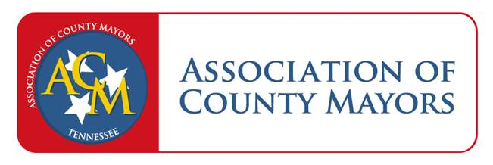
Tuesday, August 26

9:30am - 4:00pm | Registration
10:00am - 11:00am | Speaker: Commissioner Tommy Baker, TN Department of Veteran Services & Sherry Pickering,  LCSW, TN Department of Veterans Servies Outreach Coordinator | Mirabella A & B
11:00am - 11:30am | Speaker: Commissioner Jeff Long, TN Department of Safety & Homeland Security - SRO Funding | Mirabella A & B
11:30am - 1:00pm | Welcome & Introduction: Joe Carr, Rutherford County Mayor  Lunch Will Be Provided  Speaker: Commissioner Stuart McWhorter, TN Department of Economic & Community Development | Mirabella C & D
1:00pm - 2:30pm | CTAS Training – Centralized Finance - CTAS Consultants: Wesley Robertson, Kelsey Schweitzer,  Heather Duncan, Tyler Mayes & Melissa Kelton | Mirabella A & B
3:00pm - 4:00pm | Speaker: U.S. Representative John Rose, Federal Update | Mirabella A & B
4:00pm - 6:00pm | ACM Hospitality Suite – Sponsored by Konica Minolta | 2nd Floor
Evening | Dinner On Your Own
7:30pm - 10:00pm | ACM Hospitality Suite – Sponsored by Konica Minolta | 2nd Floor
Wednesday, August 27
 | Embassy Suites Provides Breakfast for Hotel Guests
8:30am - 9:00am | ACM Board Meeting | Mirabella A & B
9:00am - 10:00am | Speaker: Will Denami, Executive Director TnAAO, Property Changes | Mirabella A & B
10:30am - 11:30am | CTAS Training – More Frequent Reappraisal and Indexing  CTAS Consultants: Gabe Looney, Joe Griffin, Taylor Coker | Mirabella A & B
11:30am - 1:00pm | Speakers: Jon Walden, CTAS Executive Director  Lunch Will Be Provided  Speaker: Commissioner Deniece Thomas, TN Department of Labor & Workforce Development | Mirabella C & D
1:30pm - 2:00pm | Speaker: Becky Brock, Local Government Insurance Pool | Mirabella A & B
2:00pm - 3:00pm | Speaker: Daniel Jackson & Andy Baker, TDEC Office of Outdoor Recreation | Mirabella A & B
3:15pm - 4:30pm | Speakers: Keith Douglas & Terence Ramotar, TASA | Mirabella A & B
4:30pm - 6:00pm | ACM Hospitality Suite – Sponsored by Konica Minolta | 2nd Floor
Evening | Dinner On Your Own
7:30pm - 10:00pm | ACM Hospitality Suite – Sponsored by Konica Minolta | 2nd Floor
Thursday, August 28
8:00am - 9:00am | Breakfast for all attendees | Mirabella A & B
8:30am - 9:00am | Speaker: TN Speaker of the House of Representatives Cameron Sexton & Lieutenant Governor  Randy McNally | Mirabella A & B
9:00am - 10:00am | ACM Board Members Panel Discussion  Panel Members: Mayor Frank, Mayor Foster, Mayor Anderson, Mayor Huffman | Mirabella A & B

